Hello World Jenkins File

Login to AWS Console :

* Create an Ec2 Instance .

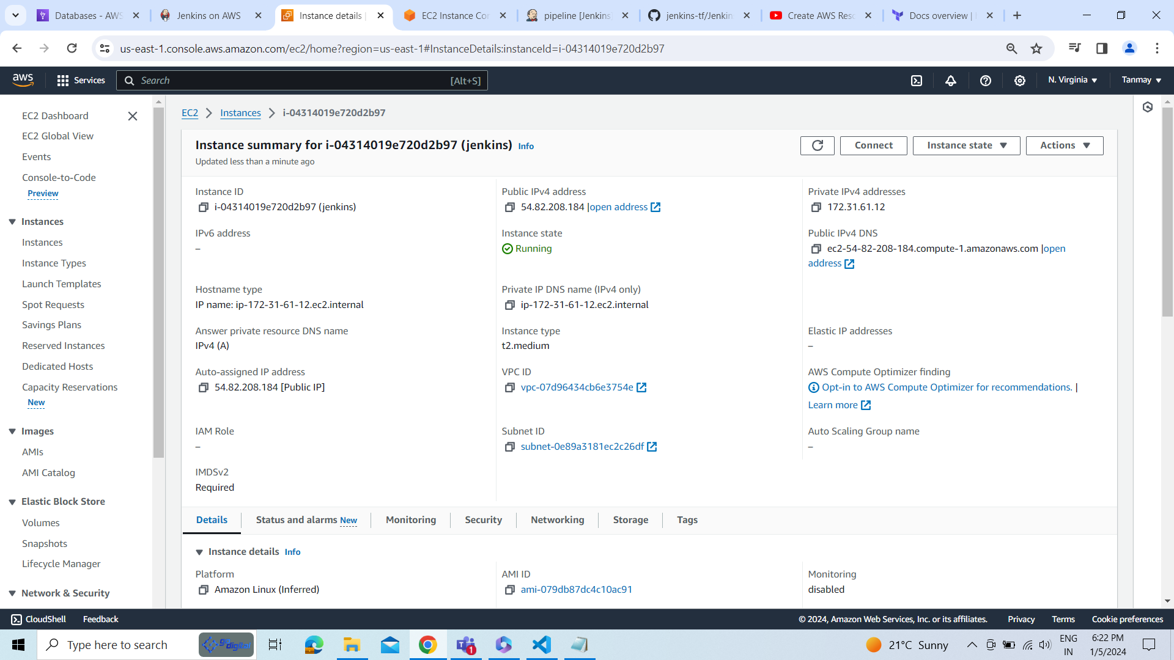

The security group of instance.

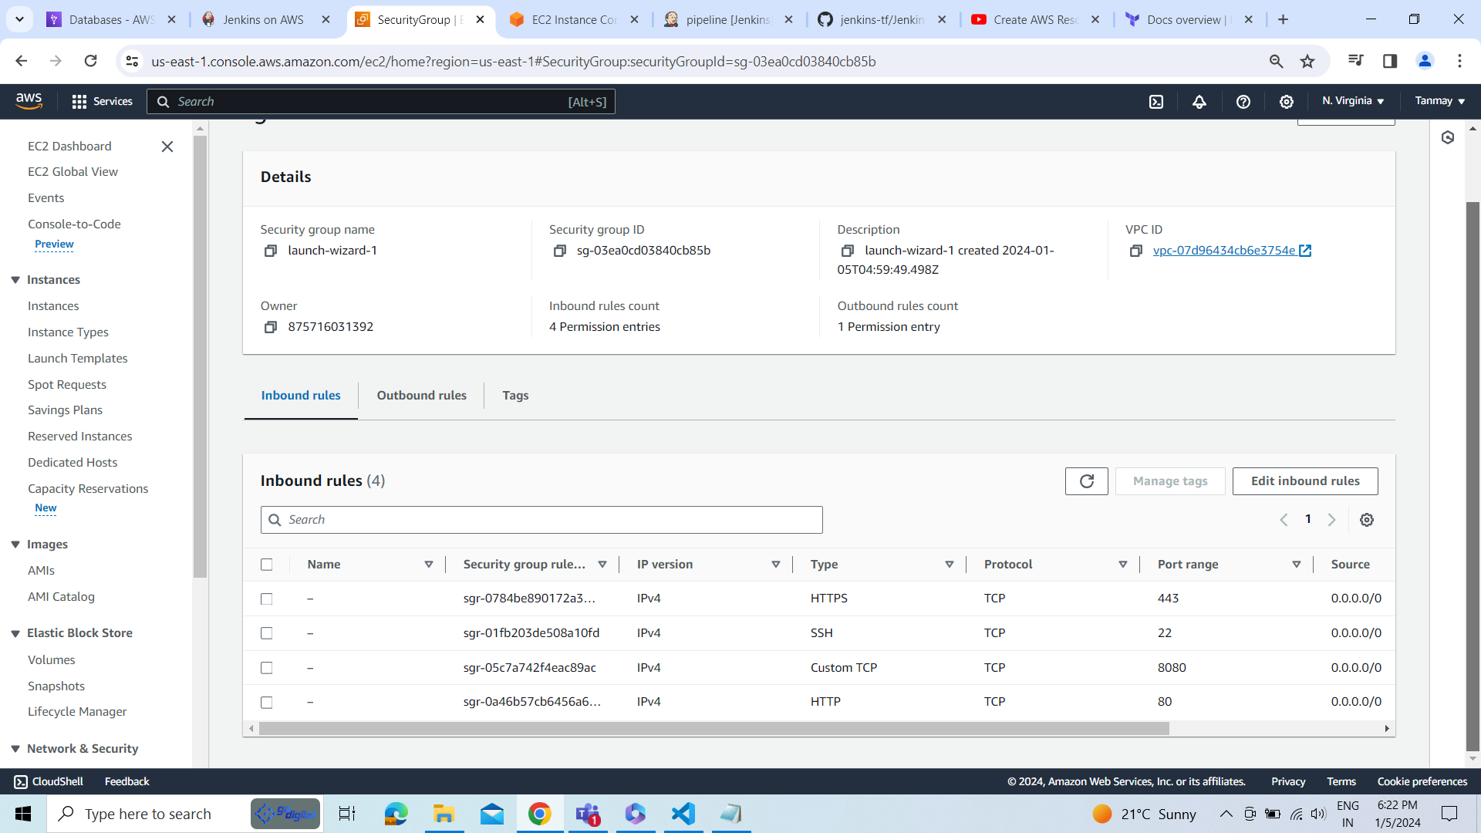

Connect the Ec2 instance through putty